Shelfbot User Manual
SB-SPEC-MANUAL · Version 3.3 · 10 September 2026

1. Introduction

1.1 Purpose
This manual describes how to operate a Shelfbot Goods-to-Person Automated Storage and Retrieval System (ASRS) safely and correctly: the safety systems and how to work with them, the daily order picking and putaway work at the stations, shutdown and restart, the inspections the customer carries out, and what to do when something goes wrong. It is written for the operators, runners and supervisors who work with the system, and for the managers responsible for them.
The Shelfbot App guides every task step by step on the operator mobile computer. This manual describes what people do at each step and what the system does in response. It does not describe individual screens, which change as the App is improved; the App always shows the next action.
Shelfbot is designed and manufactured in Australia and provided as a subscription service. All repairs, maintenance and breakdown recovery are carried out by Shelfbot.

1.2 Related Documents
Document | Used for
Shelfbot Technical Data Sheet | Technical specifications, payload limits, the handheld device specification and applied standards
Shelfbot Racking Specification | Racking, aisle and clearance requirements

1.3 Document Conventions
The following notation is used throughout this manual to communicate important safety and operational information:
Caution
DANGER: Indicates a situation presenting imminent danger, which will lead to death or serious injuries if not prevented. Additionally, there may be severe property damage.

Warning
Indicates a situation presenting possible danger, which may lead to death or serious injuries if not prevented. There may be severe property damage.

Important
Indicates a situation that may cause minor injury or property damage if not prevented.

Tip
Refers to an instruction providing further information on a particular topic.

Note
Provides information about important parts or procedures.

1.4 Prerequisites
This manual assumes the following:
- The intended operator of the Shelfbot system is capable of undertaking the necessary training and can demonstrate competence to safely perform assigned tasks.
- The intended operator is capable of undertaking training on responding to emergency or abnormal situations related to the operation of the Shelfbot system.
Note
All personnel working with the Shelfbot system must be fully conversant with the safety instructions provided in this document as well as other safety instructions applicable to this type of activity.

2. Safety

2.1 Intended Use
Shelfbot is a vertical automated storage and retrieval system for use in wholesale, retail, e-commerce, third-party logistics and small parts distribution facilities. It stores items in totes on standard warehouse racking and retrieves them on demand, presenting them to an operator at a station for picking or putaway.
The system handles totes within the payload limits given in the Shelfbot Technical Data Sheet, at high speed and precision, within a modular layout suited to the customer's floor plan. It has not been assessed for the storage of hazardous materials (refer to Storage of Dangerous or Flammable Products).

2.2 Storage of Dangerous or Flammable Products
Flammable liquids, solvents and hazardous chemicals are not permitted to be stored in the system. Customers must ensure completion of a risk assessment and PPE requirements, as Shelfbot has not been assessed to be intrinsically safe for the storage of hazardous materials.

2.3 General Safety Instructions
The contents of this section supplement the standard regulations that apply at the workplace. Users of a Shelfbot system have ultimate responsibility for safety measures concerning personnel working with the system or in its vicinity.
A Shelfbot robot can cause serious injury or death, or damage to itself and other equipment, if the following safety precautions are not observed:
Caution
DANGER: All personnel working with the Shelfbot system must have adequate training for the operation and be fully conversant with the applicable safety instructions. Incorrect usage can cause personal injury and damage the equipment.

Caution
DANGER: All personnel who install, operate, or maintain the system must read this manual and the associated technical documentation. Installation and support of the system are provided by Shelfbot technicians only.

Caution
DANGER: The system must not be used for purposes other than described in the Intended Use section of this manual.

Caution
DANGER: The operator of the system is obligated to operate it only in a safe condition. Possible personal injuries may result if it is operated in an unsafe condition.

Caution
DANGER: In the event of an Emergency Stop or Breakdown, Shelfbot Support must be contacted immediately. DO NOT USE the system until a safety audit has been completed by Shelfbot Support.

Warning
Incorrect operation of the system can lead to severe personal injuries.

Warning
The tote payload is to stay within the payload rating of the robot. Ensure that the system never exceeds the maximum payload and that totes are never filled above their top edge.

Warning
The Shelfbot system may only be used for its intended purpose, with all supplied and installed parts fully functional. All other usage is at the user's own risk. All maintenance, repairs, formal inspections and recovery from emergency stops and breakdowns must be carried out by Shelfbot or authorised personnel.

2.4 Safe Work Procedures
The following safe work procedures must be observed at all times:
- Robots may move at any time.
- Do not operate if protective guards are missing or faulty.
- Do not tamper with safety devices or interlocks.
- Do not perform any maintenance or repairs of the Shelfbot system.
- Do not climb on shelving or use it as a climbing aid.
- Report all damage and emergency stops; follow the internal procedures of your company or organisation defined for an emergency situation and report to Shelfbot.
- Do not alter the racking structure without checking with the racking designer or a competent person.
- Carry out inspections to check for correct application and use of racking, adherence to safe working loads, and impact damage.
- Ensure that correct clearances are maintained between shelves and stored totes.
- Do not wear loose-fitting garments or belts, bracelets, etc., that can become entangled when picking items. Always use the prescribed personal protective equipment.
- If in doubt, always contact Shelfbot Support.

2.5 Responsibility
Operating responsibility lies with the operator of the system. The operations manager and all operators are obligated to act according to these operation and safety instructions.
It is the supervisory staff's responsibility to arrange for the professional training of the personnel operating the Shelfbot system and to recognise known hazards associated with the robots and use them safely. Shelfbot provides a training course with each system installation.
The ongoing safety of the racking and shelves is ultimately the responsibility of the customer. Regular inspection must be undertaken to ensure the racking is in sound condition. For more information, see Maintenance & Inspections.

2.6 Limitation of Liability
The Shelfbot system is intended exclusively for use as described in this user manual. A hazard and risk assessment has been carried out in accordance with the requirements of the Australian Occupational Health and Safety (Plant) Regulations to ensure compliance of the Shelfbot design with the AS/NZS 4024.1:2019 series, Safety of machinery, and similar ISO/IEC/EN standards.
Misuse can cause danger to life and limb and impairments and damage to the robots and other material assets. Therefore:
- A Shelfbot system may only be used in sound technical condition, for its intended purpose and within the technical specifications and operating conditions, with awareness of safety and possible dangers.
- Operators must comply with the instructions of this user manual.
- Malfunctions that may impair safety must be reported and rectified immediately.
- Modifications of the Shelfbot system are not permissible.
- Shelfbot is not liable for damages caused by misuse as described above.

3. Safety Control System

3.1 Overview
Each Shelfbot is equipped with a Safety Control Panel located at the front of the robot next to the Roller Door. The control panel electrical enclosure houses the safety-related control system parts (SRP/CS) that comply with CAT 3, PLd.
The SRP/CS incorporates the following safety devices and switches:
- Safety PLC Controller, Safety CPU
- Safety Redundant Relays & Contacts
- Emergency Stop Buttons
- Interlocked Automatic Roller Door (two interlocks)
- Reset Button
The electrical enclosure is made of recessed steel secured with a key lock and is rated at IP66.

3.2 Emergency Stop vs Safeguarded Stop
The safety control interface consists of two safety functions: the emergency stop and the safeguarded stop for picking items from the Shelfbot. The differences are summarised below:
Feature | Emergency Stop | Safeguarded Stop
Robot Stops Moving | Yes | Yes
Initiation | Manual | Automatic (open Roller Door)
Program Execution | Stops | Pauses
Brakes | Yes | Yes
Motor Power | Off | Off
Reset | Manual | Manual
Frequency of Use | Infrequent | Every Picking Cycle
Reinitialisation Needed | Yes - report and contact support | No
Performance Level | Stop category 0 | Stop category 0

3.3 Emergency Stop
The SRP/CS will initiate a Category 0 Stop and apply motor brakes if any emergency stop is pressed. There are two Emergency Stop buttons for each Shelfbot: one on the Safety Cabinet and one at the front of the Shelfbot, beside the Roller Door. An additional single Emergency Stop button is located at the rear of each set of Shelfbots.
To immediately abort all running programs and stop all robot movement, press the EMERGENCY STOP button, then follow the internal procedures of your company or organisation defined for an emergency situation and immediately report the stoppage to Shelfbot Support.
The emergency stop function is a separate safety circuit only intended for emergency situations. It will immediately release all safety locks. The function is not intended to be part of a normal routine.
Warning
DO NOT reset the emergency stop switch until the fault has been reported and rectified by Shelfbot or authorised personnel.

Caution
DANGER: Entering the restricted area after an Emergency Stop is not permitted and may result in death or serious injury.

3.4 Roller Door Interlocks
Each station is fitted with a single automatic Roller Door. The Roller Door is monitored by two independent, non-latching, dual-channel coded magnetic interlocks located at the bottom of the door (Category 3, PL d).
When Shelfbot presents a tote at the station, the Roller Door opens automatically once it is safe to do so and the RESET button on the safety cabinet flashes blue. The open door trips both interlock channels and initiates a full Category 0 Stop (motor power is removed and the brakes are applied), giving the operator safe access to the tote contents while the motors remain unpowered.
Because the interlocks are non-latching, the door closing restores the interlock signal but does not, on its own, resume motion. When the work is complete the operator presses the RESET button: the Roller Door closes, power is restored to Shelfbot and the robot returns the tote.

3.5 Reset Button
The RESET button is located on the safety cabinet. It is used to reset the safety circuits for the Roller Door interlocks. The reset function prevents unintentional starting when an operator is inside the safeguarded area.
To reset the safety control system after a tote presentation:
- Ensure the work at the tote is complete.
- Ensure that the Shelfbot aisle is clear of people or fallen objects.
- Press the RESET button on the safety panel. The Roller Door closes and the robot returns the tote.

3.6 Perimeter Guards
The Perimeter Guards surrounding the system prevent access to the restricted area where moving parts of the system are activated. The protective perimeter guards are complemented with various interlocks, as detailed below.
- Automatic Roller Door: A single interlocked roller door at the front of each station, used by the operator to access presented totes. It is monitored by two non-latching, dual-channel interlocks at the bottom of the door; opening it removes power to the robot actuators (safeguarded stop).
- Back Door: A hinged fixed panel attached with security bolts. Only accessible by Shelfbot authorised personnel for installation, support, and maintenance.
- Racking Guards: The exposed sides of the racking are covered with materials permanently fixed to the racks, maintaining a safe distance from the Shelfbot robot.
Caution
DANGER: Do not remove any perimeter guarding. Access is not permitted to the restricted area and may result in death or serious injury.

3.7 Motor Brakes
Shelfbot incorporates brakes on all motors. The brakes are applied and motors disabled automatically in the event of an emergency stop, power failure, or when the system is put into REST mode. Brakes are also applied during normal operation when Shelfbot presents a tote at the station and the Roller Door is opened.

3.8 Signage

3.8.1 Safe Working Loads
The SWL sign must be positioned in a conspicuous location adjacent to the Shelfbot system. The sign is provided and installed by the racking installer and must be mechanically secured as per Australian Standard AS4084 or the installation region's related specification.
The tote payload, shelf load and bottom beam height shown on the sign are those given in the Shelfbot Technical Data Sheet.

3.8.2 Safe Work Procedure Signage
The Safe Work Procedures signage is mounted next to the SWL sign and must display the required danger, warning, and caution messages as specified in Safe Work Procedures.

4. System Components
Each Shelfbot installation consists of one or more robots working inside aisles of standard racking, a station at the end of each aisle, put-to-light trolleys behind the operators, and a server cabinet. Each robot carries an identification label showing the model, serial number and manufacture date.

4.1 Robots
Each robot consists of a top car and a bottom car running on fixed rails at the top and bottom of the racking aisle, and a suspended platform. The cars drive the robot along the aisle; the top car hoists the platform up and down the racking face. The platform extends its arms to pull a tote from its shelf onto the platform, carries it to the station, and pushes it back onto its shelf afterwards. Refer to the Shelfbot Technical Data Sheet for dimensions, masses and performance.

4.2 Racking
The system is installed on standard steel pallet racking compliant with AS 4084, at the frame depth and aisle width set out in the Shelfbot Racking Specification. The exposed sides of the racking are guarded (refer to Perimeter Guards). The racking, its safe working loads and its condition remain the customer's responsibility (refer to Maintenance & Inspections).

4.3 Stations
The station is the end of a robot aisle, where the robot presents totes. There is one station per robot. Each station has an interlocked automatic roller door through which the operator reaches the presented tote, and a safety control panel with the emergency stop and the blue RESET button (refer to Safety Control System). A block of adjacent stations served by one operator is a zone, identified by its robot numbers (for example robots 1 to 3).

4.4 Totes
The Shelfbot tote is an open-top storage container supplied by Shelfbot in a range of standard sizes; the system works only with Shelfbot totes and attachments. A tote holds one or more SKUs. Totes must never be filled above their top edge, and the item and tote payload limits in the Shelfbot Technical Data Sheet must not be exceeded. The platform weighs each tote as it is handled, and the App alerts the operator when a tote is near or over its payload. The App also refers to a tote as a bin.

4.5 Put-to-Light Trolley
Behind each operator stands a put-to-light trolley: a wheeled frame of shipper positions with one lamp per position, on lockable castors. There is one trolley per zone; the number of positions and levels is set by the site's shipper sizes. The operator works the front of the trolley and the runner works its rear; neither reaches across the other. A shipper erection table stands beside the trolley line.
A shipper is the container an order is picked into: a shipping carton, or a reusable order tote. The customer erects, labels and supplies shippers; the label carries the customer's own shipper code, which the App scans to bind the shipper to a position and its order. Shelfbot decides which order goes into which shipper as it is inducted. An order is picked into one shipper or, when a shipper fills before the order is complete, into several one after another; an order with lines in more than one zone continues in its current shipper, which the runner carries between trolleys.
The trolley stays in its marked position with its castors locked during operation. It is moved only to clear the front zone, for example for maintenance access, with the path clear of people and obstacles.

4.6 Operator Mobile Computer
The Shelfbot App runs on the operator mobile computer: a customer supplied handheld mobile computer with an integrated barcode scanner, minimum specification in the Shelfbot Technical Data Sheet. Each operator and the runner carries one. Items, shippers and positions are scanned with the device's integrated scanner, so no separate barcode scanner is needed.
The devices are charged with the customer's own chargers, cradles and spare batteries. Charge each device, or swap in a charged battery, at the end of every shift so that a charged device is ready for the next shift.

4.7 Server Cabinet
The Shelfbot server runs in a secure cabinet installed at the racking. The cabinet houses the server, the network equipment and an uninterruptible power supply. The server coordinates the robots, runs the App, exchanges SKU, order and inventory data with the customer's WMS, and replicates to the Shelfbot cloud for monitoring and support. If the site connection is lost, the system keeps operating locally on the orders already received. The cabinet is opened only by Shelfbot.

5. Operation
Tip
All robot operations can only be performed when the perimeter guards are in place, and can only be initiated from outside the restricted area.

5.1 Roles
Role | Duties
Operator (one per zone) | Picks from the presented tote and puts to light into shippers on the trolley. Stocks presented totes during putaway. Does not handle shippers.
Runner | Supplies and inducts shippers, swaps completed orders onto the takeaway, transfers split orders between trolleys, scans and stages putaway stock. Works to the App's instructions. Does not pick or put.
Supervisor | Manages user accounts, carries out the monthly inspection, responds to emergency stops and contacts Shelfbot Support.

The takeaway is where completed shippers go: the customer's takeaway conveyor, or a packing station behind the runner aisle. Packing and dispatch follow the customer's existing processes and are outside this manual.

5.2 The Shelfbot App
The App is the point of control for the system. It shows each person their current task: the tote and quantity to pick, the lit position to put into, the shipper to induct, the stock to stage, or the tote to stock. Scanning confirms each step; where the App asks for a confirmation, give it. The App always shows the next action, so follow the App rather than working ahead.
Orders and SKUs come from the customer's WMS automatically. Nothing is created in the App: if an order or a SKU is missing, correct it in the WMS.

5.3 Logging In and Out
Each person logs in with their own operator ID and PIN. A login is personal: two people must never share one, because the system records who did what. The App logs a user out automatically after a period of inactivity, and after 12 hours at most. Log out at the end of every shift.
Tip
At shift changes the current operator logs out so the next operator can log in on the same device. Two operators cannot share a login for safe operation.

5.4 User Accounts
The customer manages its own users. A user with Admin or Super privileges creates accounts, assigns roles and removes users who leave. Three roles are enforced:
Role | Capabilities
Operator | Pick, putaway and reset operations
Admin | User administration and reporting, in addition to Operator capabilities
Super | System administration, in addition to Admin capabilities

Deleting a user is permanent.

5.5 Working at the Station
Every tote presentation follows the same safety cycle, whether for picking or putaway:
- The robot presents a tote at the station. The blue RESET button on the safety control panel flashes.
- The Roller Door opens automatically when it is safe to do so, and the App directs the operator to the active station in their zone. While the door is open the robot is held in a safeguarded stop: motor power is removed and the brakes are applied.
- Do the work the App shows (pick or putaway), scanning as directed.
- When the work is complete, press the blue RESET button. The Roller Door closes, and the robot returns the tote to storage and fetches the next one.
Warning
Reach into a presented tote only through the open Roller Door, and only for the pick or putaway the App shows. Never reach past the tote into the aisle.

If the door does not close or the tote does not return after RESET is pressed, refer to Troubleshooting.

5.6 Order Picking
Each operator works their own zone at their own trolley; one runner works behind the trolleys.
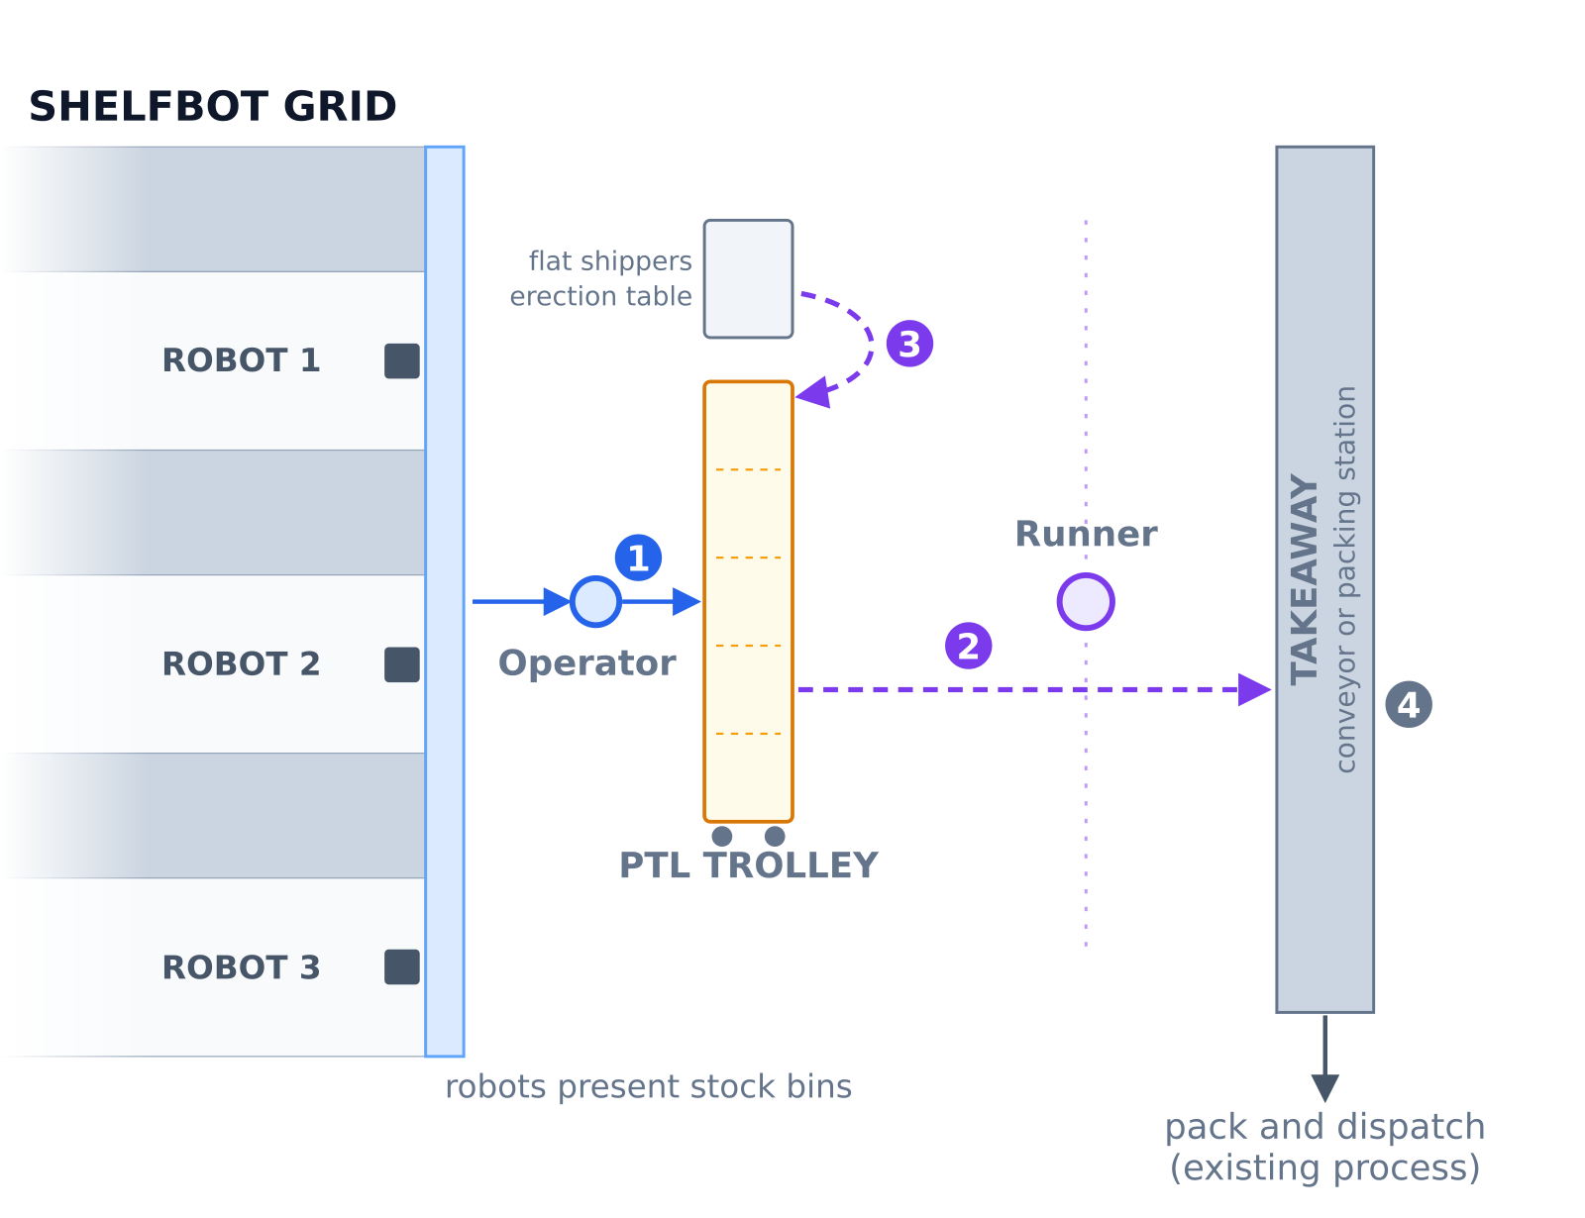
Figure: Order picking flow, single operator

5.6.1 Pick and Put (Operator)
- A robot presents a tote. The App shows the SKU and the quantity to pick.
- Scan an item from the tote. The App confirms it is the right SKU.
- Pick the quantity shown. A position on the trolley lights with the quantity to put into that shipper; put it and confirm the put as the App directs. If more than one order on the trolley needs the SKU, the positions light one after another.
- Press the blue RESET button. The Roller Door closes and the robot returns the tote. Move to the next active station when the App directs.

5.6.2 Shipper Swap (Runner)
- A position shows complete or full. Lift the shipper off the rear of the trolley onto the takeaway. A complete shipper closes its order; a full shipper goes to packing while its order continues in a fresh shipper.
- The App calls the shipper size for the next shipper: a fresh one for the same order when the last was full, otherwise for the next order. Place a fresh shipper of that size in the freed position and scan it. The scan binds the shipper to the position and its order and returns the position to service.
- A label the App reports as still bound to an open order cannot be used; take a different shipper. An order tote becomes free for reuse once the customer's WMS has closed the order it carried.
The operator continues picking throughout; the swap does not interrupt the zone.

5.6.3 Shipper Supply (Runner)
Keep a stock of erected shippers of each size at the erection table, using the site's carton erector where one is fitted, and restock it between tasks. The App reports the shipper stock to hold per size.

5.6.4 Split Order Transfer (Runner, grids with two or more zones)
An order with lines in more than one zone continues in its current shipper, which the runner moves between trolleys.
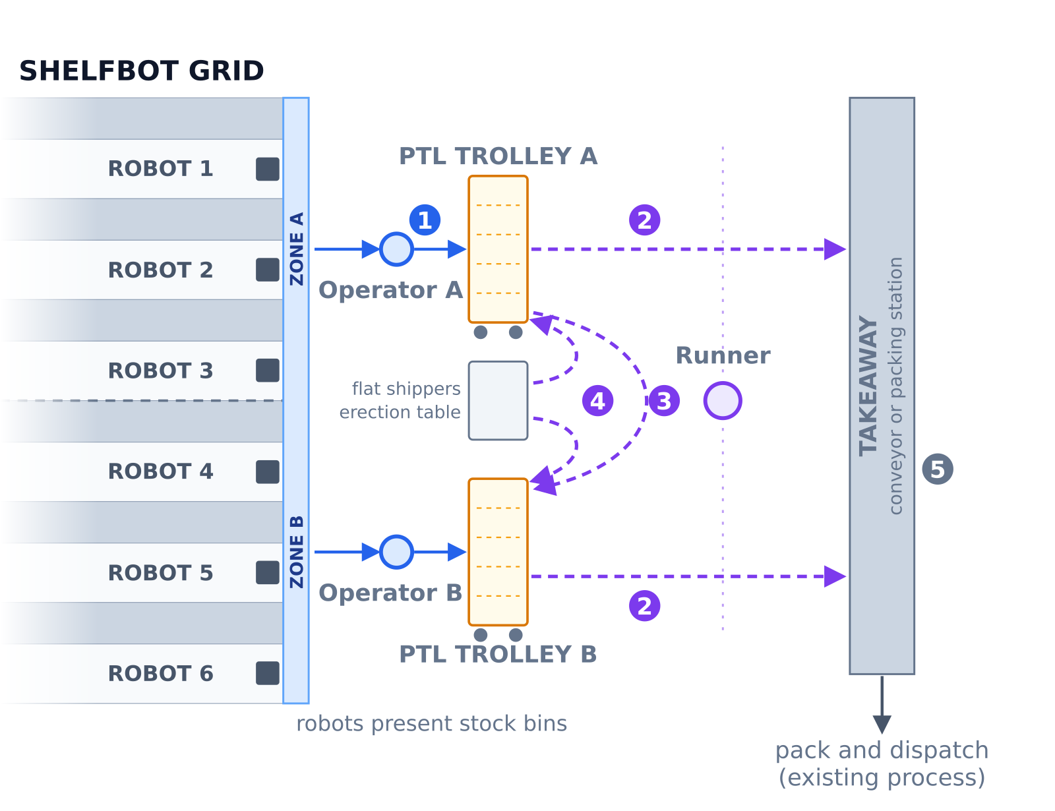
Figure: Order picking flow, dual operator
- A position shows transfer, with the destination trolley. Lift the shipper off the rear of the trolley.
- Carry it to the destination trolley, place it in any free position that fits the shipper size, and scan it. The remaining lines bind to the new position.
- If no position is free, the shipper waits beside the destination trolley until one is.
The final zone completes the order, which then leaves by the completed order swap. At low volumes one operator may work both zones, moving between the two trolleys; the layout and the flow are unchanged.

5.6.5 Pack and Dispatch (Customer)
Completed and full shippers are packed and dispatched under the customer's existing processes, at the packing station(s), or after travelling a takeaway conveyor for manual order consolidation. The customer's WMS learns which order lines each shipper holds through the Shelfbot API (refer to the Shelfbot API document), so scanning the shipper label at packing identifies the order and its contents. Order totes return to the trolley for reuse once the WMS has closed the order.

5.7 Putaway
Putaway brings stock into the grid through the same stations. The runner receives and stages the stock, the robot brings the chosen tote, and the operator stocks it.
- Scan (Runner). Scan the inbound SSCC (the GS1 identifier on an inbound carton or pallet) or the SKU barcode. For a batch-tracked SKU the App shows the batch and expiry it read from the label or received from the WMS for that carton; confirm them, or key them if the label carries neither. Stock cannot be put away without them.
- Tote decision (System, or Operator). The system selects the tote to bring to the operator, using the SKU's stored default (whole tote or divided tote), the distribution of the SKU across the grid, velocity slotting, and the batch, FIFO and FEFO rules configured for the site. The App also lists every tote already holding that SKU, with a photo and the current weight of each; where the rules allow, the operator may select one of these to top up instead.
- Robot assignment (System). The system identifies the robot that will bring the tote and tells the runner where to stage the stock.
- Stage (Runner). Place the inbound carton or items on the trolley at that robot's location, ready for the operator.
- Stock and confirm (Operator). When the tote is presented, stock it as the App shows, confirm the quantity, check the weight the App reports, then press the blue RESET button to close the door and return the tote. A batch-tracked SKU goes only into a compartment holding the same batch or an empty one; the App will not offer a compartment that holds a different batch.
Important
Never fill a tote above its top edge, and never exceed the item and tote payload limits in the Shelfbot Technical Data Sheet. If the App reports the tote over its payload, remove items until the weight is within limits.

5.8 Exceptions
- Fewer units in the tote than expected. Pick what is there. The App asks for the count remaining in the tote before it releases the tote; enter it. The shortfall is reported to the WMS and the order continues.
- Barcode cannot be scanned. The App allows the pick to be confirmed manually. Every manual confirmation is recorded and reported to the WMS, so use it only when the barcode is missing or unreadable.
- Weight alert. If the App reports a tote near or over its payload, remove items until the weight is within limits before returning the tote.
- Tote does not return. Press RESET again. If the door does not close or the tote still does not return, refer to Troubleshooting.
- Jam or fault. Do not attempt to free a jammed robot or tote. Press the emergency stop only if there is a hazard to a person. Contact Shelfbot Support.
- Emergency stop. Follow Emergency Stop: report it, do not reset until Shelfbot Support has cleared the system, and never enter the restricted area.

5.9 Finding Stock
The App finds a SKU by scanning its barcode, or by searching on the barcode or any text from its name, and shows every tote holding it with the quantity, weight and location. A tote can be called to the station outside the pick flow for a stock check or a manual retrieval. Every item taken from or added to a tote must be scanned, or the Shelfbot inventory and the WMS will disagree (refer to Troubleshooting).

6. Shutdown & Restart
Warning
Contact Shelfbot Support prior to Shutdown and Restart.

Under normal operation, a full shutdown of the system is not required.

6.1 Rest Mode
The system automatically enters a REST mode after a period of inactivity. This drives the platform to its ground position and removes all power to motors and actuators. All interlocked doors and panels remain locked, safeguarding the system from unauthorised access. The system wakes when work resumes.

6.2 Shutdown Procedure
Caution
DANGER: Shutdown of the system releases the interlocks, so the Roller Door is free to open, allowing access to the restricted and safeguarded space. Operator access to these areas without undertaking a full risk assessment is not permitted and presents imminent danger, which can lead to death or serious injury. Contact Shelfbot Support prior to Shutdown and Restart.

Shutdown is not required under normal operation. Shutdown of the system must be completed in an orderly manner on each Shelfbot robot as follows:
- Contact Shelfbot Support to review the steps.
- Undertake an independent risk assessment.
- Ensure all totes are safely on shelves.
- Ensure security bolts are installed on the Back Door.
- Reset the system from the App and wait for it to report idle.
- Put the system to rest from the App and wait for it to report at rest.
- Ensure all Shelfbots are safely at rest with platforms at ground level.
- Power off the Shelfbot at the Safety Cabinet isolator switch.
- Lock Out Tag Out at the Safety Cabinet isolator switch.
- Install a Safety Barrier Tape across the front of the Shelfbot.

6.3 Restart Procedure
After a Shutdown, the system must be restarted on each Shelfbot in an orderly manner as follows:
- Contact Shelfbot Support to review the steps.
- Undertake an independent risk assessment.
- Ensure security bolts are installed on the Back Door.
- Ensure all totes are safely on shelves.
- Remove the Safety Barrier Tape across the front of the Shelfbot.
- Remove the Lock Out and Tag Out at the Safety Cabinet isolator switch.
- Power on the Shelfbot at the Safety Cabinet isolator switch.
- Wait for each Shelfbot to connect and show ready in the App.
- Wake the system from the App and wait for it to report idle.

7. Maintenance & Inspections

7.1 Maintenance Schedule
Shelfbot maintenance is performed according to the schedule below. Customers will be notified about upcoming services once the system reaches interval milestones.
Activity | Component | Interval
SERVICE | Cars | 10,000 km or 12 Months
SERVICE | Platform | 100 km or 6 Months
OVERHAUL | Platform | 2,000 km or 24 Months

7.2 Monthly Visual Inspection
The customer is required to undertake a monthly inspection of Shelfbot and the racking according to the Inspection Checklist below. This is a visual inspection performed from outside the safeguarded area.

7.3 Inspection Checklist
Inspections shall include the following checks:
- Ensure that unit loads adhere to specified dimensions to maintain specified tote clearances.
- Check the stability of totes. No totes sticking out or items/objects visible within the aisle.
- Check if the racking installation has been modified using SWL and Installation signage.
- Ensure that all signage is current, legible, and free from damage and obstruction.
- Verify that all racking components including frames, beams, floor fixings, bracing, and ancillary devices are consistent with the design.
- Assess for damage to racking uprights, beams, baseplates, and frame bracing caused by impact.
- Check for out-of-plumb (non-vertical) racking uprights in both the cross-aisle and down-aisle directions.
- Identify any corrosion of racking components.
- Examine the floor condition, checking for signs of deformation, out of level, and cracks.
- Assess if forklift protection barriers are securely fixed, if applicable.
- All guarding and panels around the Shelfbot zone are straight and undamaged with no loose fittings.
- Confirm that all perimeter guards are undamaged and locked.
- No loose materials, hanging cables, or fittings directly above the Shelfbot structure.

8. Troubleshooting & FAQs

8.1 Troubleshooting

8.1.1 Over Filling
Overfilling a tote beyond the top edge may result in a jam or dislodgement of adjacent totes on a shelf. Operator discretion is required to ensure items placed in the tote do not exceed the top edge. If a tote is over-filled or a jam occurs, immediately contact Shelfbot Support and shut down the system.

8.1.2 Over Weight
When inserting items into totes, Shelfbot will alert the operator if the total tote weight exceeds the defined payload. Shelfbot will only send a notification when the tote is near to or over weight. It is the responsibility of the operator to remove items from the tote until the weight has stabilised under the defined payload.

8.1.3 Resetting the Safety Control System
If a tote remains at the station after a pick or putaway, press the blue RESET button on the control panel. The Roller Door closes and the button reverts to a steady blue light once the safety control system is reset.
If the door does not close, the blue light is still flashing, or the interlock shows a RED light, the interlock may have failed to latch fully and lock the Roller Door. Please contact Shelfbot Support.

8.1.4 Inventory Discrepancies
Taking or placing items into a tote without scanning the item into the Shelfbot system will result in an inventory discrepancy between Shelfbot and the external system. The operator must ensure that every item is scanned in or out of the Shelfbot tote.
Shelfbot will produce a report based on the inventory discrepancy between Shelfbot and the external system when observable and observed.

8.1.5 Jams
Do not attempt to release a jammed robot. Contact Shelfbot Support. The operator must complete an independent risk assessment before entering the Shelfbot restricted area.

8.2 Frequently Asked Questions
Can I use the Emergency Stop button to enter the Shelfbot restricted area? No. The Emergency Stop button is for emergency stops only. Pressing it will immediately stop all robots in the Shelfbot system. This action will immediately notify Shelfbot Support and require a manual reset of the entire system.
What is the flashing blue button for? The blue button on the Safety Cabinet is a RESET button. Once a tote is presented at a station and the Roller Door has opened, the blue button flashes. When the work is complete, press it to close the door, reset the robot safely and allow the tote to return. If the button continues to flash, press it again; if the door still does not close, contact Shelfbot Support.
How do I add new SKUs to Shelfbot? Use the external system (the customer's WMS or e-commerce platform) to add new SKUs. Once added to the external system, they are pushed to Shelfbot automatically.
How do I add an Order to Shelfbot? Orders are managed by the external system. They are pushed to Shelfbot automatically and appear in the Shelfbot App.
What happens if an Order cannot be fulfilled by Shelfbot? Accurate inventory management on the external system is critical. When inventory has been assigned to Shelfbot, the operator must ensure that items have been physically added into Shelfbot totes prior to picking orders. Shelfbot will only attempt to fulfil order lines that are held in Shelfbot inventory.
What happens if there is a jam? Do not attempt to release a jammed robot. Contact Shelfbot Support. The operator must complete an independent risk assessment before entering the Shelfbot restricted area.

9. Appendices

9.1 Glossary
Term | Definition
Authorised Personnel | Individuals who have received proper training and authorisation to operate, maintain, or access the Shelfbot system.
CAT 3 | Category 3 function of a safety control system. Provides fault detection and maintains the safety function in the presence of a single fault.
Emergency Stop | An action or device used to immediately stop the robot in hazardous situations. Also referred to as E-stop or ESTOP.
External System | Any system that interfaces with the Shelfbot system, such as a WMS or ERP system.
FEFO | First Expired, First Out. An inventory rule under which the stock with the earliest expiry is used first.
FIFO | First In, First Out. An inventory rule under which the first items received are the first items used.
Operator | The person who picks from presented totes and puts into shippers on the trolley, and stocks totes during putaway. One per zone.
PLd | Performance Level d. Indicates the ability of safety-related parts to perform their safety function under foreseeable conditions.
Position | One shipper place on a trolley, with its own lamp.
Put-to-Light (PTL) | A light-directed method where the destination position illuminates to show the operator where to put a picked item and the quantity.
Restricted Area | The designated space established by physical or virtual means to limit motion and prevent unauthorised access.
Runner | The person behind the trolleys who handles shippers: supplying erected shippers, inducting, swapping completed shippers onto the takeaway, transferring split orders and staging putaway stock.
Safe State | A condition where the system is stopped, the platform lowered, and doors closed, ensuring no hazardous movement can occur.
Safeguarded Space | An area enclosing a hazard zone where guards and/or protective devices are installed.
Safety Cabinet | An enclosure containing safety-related controls and components of the Shelfbot system.
Shipper | The container an order is picked into: a shipping carton or a reusable order tote, labelled by the customer. An order may fill several shippers in turn.
SKU | Stock Keeping Unit. A unique identifier for each distinct product or item for inventory tracking.
Split order | An order with lines in more than one zone.
SRP/CS | Safety-Related Parts of Control Systems. Components preventing hazardous conditions.
SSCC | Serial Shipping Container Code, the GS1 identifier on an inbound carton or pallet.
Station | The end of a robot aisle, where the robot presents totes for picking and putaway. One per robot.
Swap | The exchange when a shipper is complete or full: the shipper off the trolley onto the takeaway, a fresh shipper into the freed position.
Takeaway | Where completed shippers go: the customer's takeaway conveyor, or a packing station behind the runner aisle.
Tote (bin) | The storage container for items, carried between its shelf and the station by the robot. Called a bin in the Shelfbot App.
Transfer | Carrying a part-finished split order shipper from one trolley to the next.
Trolley | The put-to-light trolley behind the operator: a wheeled frame of shipper positions, one lamp per position. One per zone.
WMS | Warehouse Management System. Software managing warehouse, distribution centre, or fulfilment centre operations.
Zone | A block of robot aisles serviced by a single operator, identified by its robot numbers (for example robots 1 to 3).

9.2 Safety Assessment and Standards
The standards the Shelfbot system is designed to are listed in the Shelfbot Technical Data Sheet (Compliance).
A plant safety risk assessment of the Shelfbot system was undertaken by Jason Lim of Plant Safety Solutions Pty Ltd on 24 May 2024. The focus of this assessment is the safety of machinery for compliance with the recommendations of AS/NZS 4024 Safety of Machinery, where reasonably practicable, to meet the requirement of the OHS Act in the provision of safe plant. For a copy of the full report, please contact Shelfbot Support.

9.3 Support
For all support enquiries regarding Shelfbot, call us on +61 3 9069 5000 or the assigned representative for your region.

9.4 Revision History
Version | Date | Change
3.1 | 19/08/2026 | Published to Web Site
3.2 | 10/09/2026 | Rewritten around the put-to-light trolley and runner process flows, which replace the screen-by-screen operation chapter; Put Wall and Conveyor removed; technical specifications, integration and standards now referenced from the Technical Data Sheet and IT Integration; operator iPads replaced by customer supplied mobile computers
3.3 | 10/09/2026 | An order may fill several shippers in turn: shipper definition, shipper swap (complete or full), split order and packing steps revised; order totes reused once the WMS closes the order

